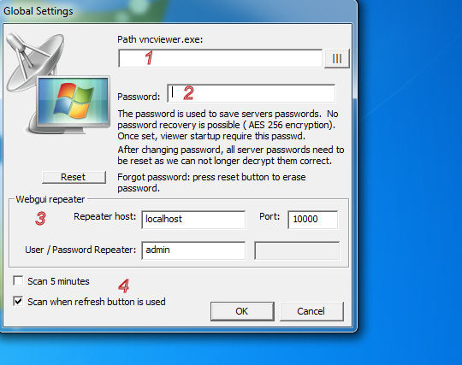Global settings
- If UVNC_Launch is in another folder then vncviewer.exe, you need to set the path of the viewer. The default install folder in “program files” is not writable for all users, if a normal user need to be able to change settings you need to copy the VNCLaunch.exe to a writable folder.
- If set, you need to enter this password each time VNCLaunch is started. The password is used to encrypt server user and/or password. If you forgot the password, you need to remove the config file (./uvnc/uvnclauch.ini)
- The launcher can get the status for the repeater, you need to enter the webgui settings of the repeater. If you have multiple repeaters, you can overwrite this global value with a server based value.
- The launcher check if the server/repeater and repeater ID are online. If many defined servers are ofline the scan can take long to complete.

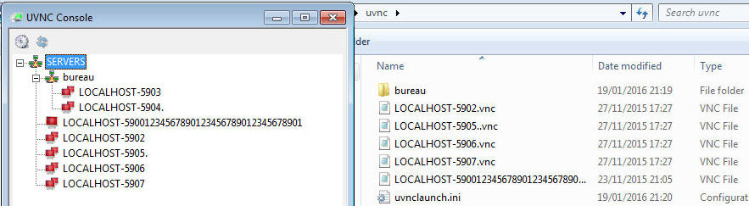UVNC Console
On start you see the folder structure and .vnc of the uvnc subfolder?
You can manual add .vnc files to the folder saved by the vncviewer.exe. Right click (1) and “Save connection info as..(2) Don’t save the password, it’s better to set it via “edit .vnc”
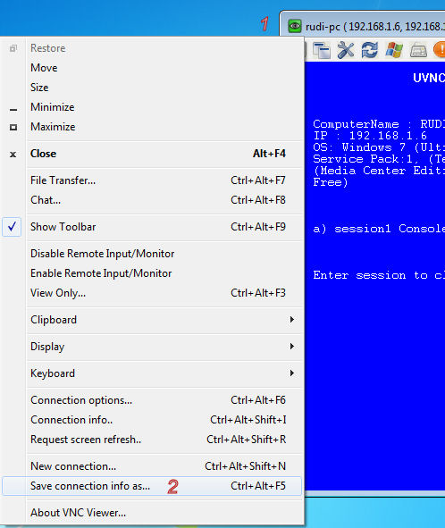
Or add if from the “UVNC console” window.
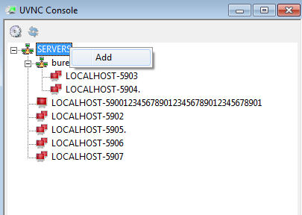
Each server (.vnc) has multiple options (A). 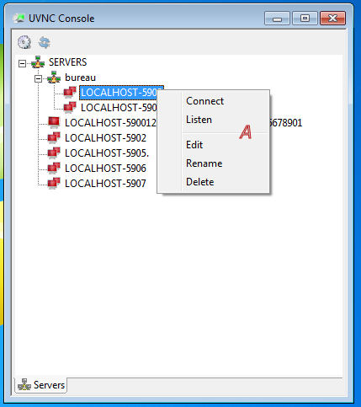
Connect: Viewer connect to server.
Listen: Start a listening viewer on port (B)
Edit: Opens a .vnc editor
Rename: rename the filename of a .vnc file
Delete: remove a .vnc file.

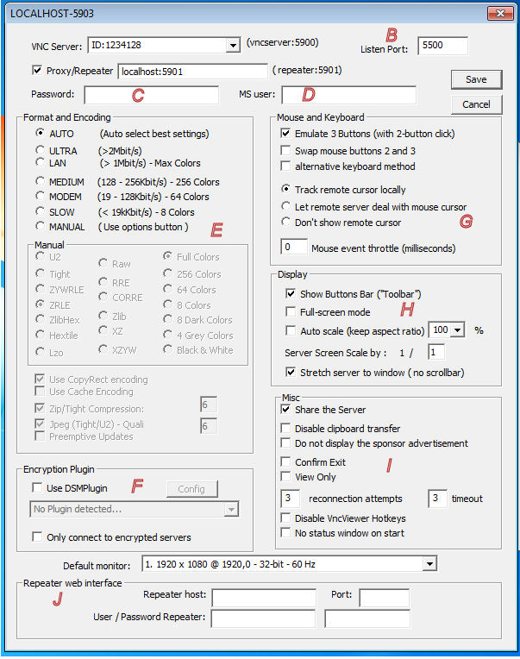.vnc editor
B: Listen port
C en D: Server user and or password. ( If a plugin is used, this can also be the passphrase). Both C en D are saved in the .vnc file and encrypted using the global settings password 1.
E, G, H, I: viewer connection options
F: server-viewer encryption
J: If you use multiple repeaters, you can overwrite the global defined repeater via a .vnc based settings

